Student Name: Xianglong Lin Student Number: 45791439 Team Name: H2OMG
Week: _5_
Title: User Needs, Problems and Water-Saving Design Solutions
Description:
In the 5th week, our team analysed the interview data collected on tracking water usage immediately after implementing ethical considerations in the 4th week. We tried to use affinity diagrams to organise and fully understand the collected data, which visualises and categorises relevant qualitative data that is key to influencing design decisions and solutions.
The affinity diagram analysis reveals 4 important insights:
- Needs: Most users have a strong need for water awareness, and therefore desire real-time monitoring and notifications to better manage their water consumption. On the other hand, efficient water use and cost management are also valued. Users hope that there is a tool on the market to detect and inform of leaks and excessive usage.
- Problems: The issue of water waste is one of the more prominent problems, based on a lack of awareness and measures to save water. Users are usually frustrated by the increased water bill but also worried about how to track individual usage in a multi-person living environment.
- Values: Users are focused on sustainability awareness and cost-effectiveness, preferring more environmentally friendly solutions without compromising convenience or sacrificing practicality. Meanwhile, comfort and convenience are also particularly important. The system is expected to seamlessly integrate with users' daily lives while minimising disruption of traditional habits.
- Emotions: The data covers a complex mix of emotions, including concern for resource conservation, practicality, and strong environmental awareness. This is manifested in users feeling satisfied and proud when contributing to resource conservation, but also experiencing frustration due to a lack of efficient tools and relevant knowledge.
Visual Evidence:
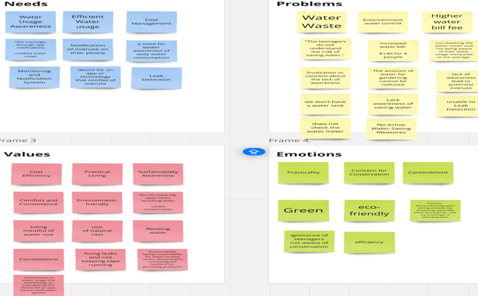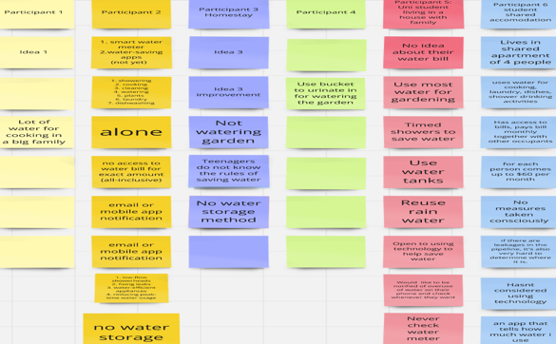
Statement on Learning:
This studio used affinity diagram analysis data to demonstrate the importance of organising qualitative data into meaningful categories. User needs, problems, values, and emotions reveal the design areas of solutions while helping us understand data. One learning experience is that organised data analysis is good at being used to discover user pain points that are not easily detected. For example, the waste of water resources is often closely related to users' lack of awareness and measures for saving water. Therefore, simply developing monitoring tools is not enough; instead, solutions that provide feasible suggestions are needed. For example, the system can propose specific measures to reduce water consumption based on users' habits or patterns of using water. For instance, it can suggest shortening the time for watering gardens and reducing unnecessary flushing to lower water bills.

